# Extreme Mini Golf Deluxe Edition

## Core concept

the user must manoeuvre a golf ball towards a goal on a mini golf course. There will be obstacles and hazards that block the player from being able to complete the course.

## Design pillars

Manoeuvre the Golf Ball

Avoid The Obstacles

Set a High Score

## Main features and mechanics

### Movement

Drag back and Release to move the golf ball. This takes inspiration from the game Dunk Shot

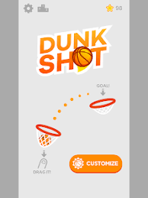

### Obstacles

#### Regular

Block the player from the finish of the level. The ball would just bounce off these such as a wall or a raised platform

#### Hazards

Player will restart level / checkpoint if collided this is something like a blade of a spinning windmill that the player must time to get past it.

Windmill

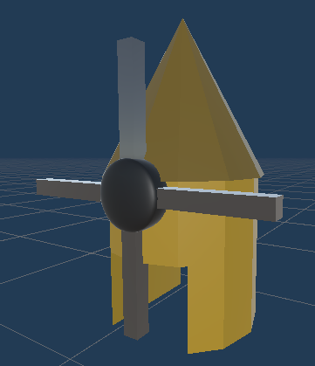

This is the base model of the windmill, there is a spinning blade that will make it harder for the player to get past it. There is a faster version of the windmill which appears in later levels.

This is the walls obstacle. The Player has to move around the two walls. Its possible to do an angled shot to get past this obstacle. In one attempt

Ramp

The player has to get over the ramp without falling out of bounds

### Score

The player score is calculated based on the number of moved used to get passed one of the obstacles. The goal is to sink the ball in the least amount of hits possible.

### Checkpoints

Checkpoints mark the safe point of the area. Once the player reaches a checkpoint if they fail their progress will be reset from this point checkpoints are always in front of the last obstacle entered

## Limited Respawns / Balls

When the player respawns, they will lose one of their balls. Once they run out the game will restart the entire level / course rather than from the last saved checkpoint

## Target platform and audience

Android Mobile Developed in Unity

## Interface and controls

Touch screen / mobile device

Tap and hold the screen at a point behind the ball to display the shot meter. Release to make the ball move. You can also drag from the ball to get the same results.

## Basic story

3 Levels

The first level will have 1 of each of the obstacles

Level 2 and 3 will both contain several of each obstacles and a more difficult version of the windmill that spins a lot faster than the regular version

## Visual style

Environments would represent a mini golf course

3D perspective camera sits behind the ball looking down

Initial design sketches.The above sketch is a possible hazards for part of the level. The 2D side scroller perspective is not used

A: Hoop. Player has to have enogh momentum to pass through the hoop into the next zone

B: Windmill. Classic mini golf obstacle. Player has to time correctly to avoid being hit by the windmill blades.

This is how the windmill obstacle could be represented in 3D

The 3D perspective will allow for the obstacles such as this where the player has to bounce off the edges of the course to complete the zone

## Audio style

Bouncing sounds

Outside environment sounds

Background music

## Known issues and bugs

Level 3 does not load

It is possible to jump the barriers

The help arrow does not appear at the start of the game

## Future improvements

The ability to manually respawn was suggested , so when the player is stuck in a corner, there would be a button to respawn to the middle of the track.

Extending the variation of the levels would improve the re-playability of the game.

Adding additions such as corners would make the levels more interesting.

Larger range of obstacles and improved level design

Another suggestion was to help with the ball getting stuck on the side so an ability to rotate the camera would allow the player to be able to aim more precisely.

From the user feedback I think I would make the scoring system more standard and have each shot count towards one point rather than only increasing in the obstacle sections.

For re-playability it was also suggested that the high score should be visible while playing, to give players motivation to try and get a better score.

## Google Play

<https://play.google.com/store/apps/details?id=com.ChaseBennettHill.ExtremeMiniGolfDeluxeEdition>.

Presentation

If the link expires the video is available in the repo

[Chase Bennett-Hill Mobile Presentation 1.mp4](https://otagopoly-my.sharepoint.com/:v:/g/personal/bennc9_student_op_ac_nz/Ec4jfXnMqDNDhBCimLBLz6UB02ow-N-3iLVTXrg8jDzloQ?e=QBBvGk)